**Build Results**

1. Synthesis:
2. 50MHz:

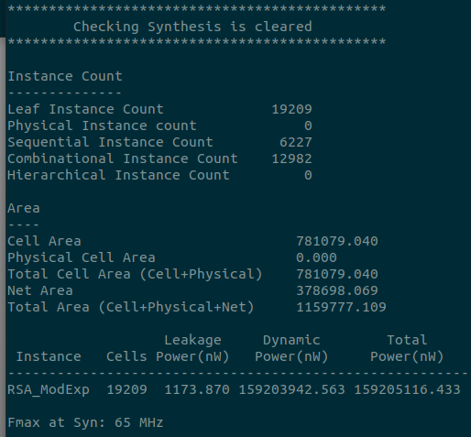

|  |  |
| --- | --- |
|  | ROHM |
| Sequential Instance | 6227 |
| Combinational Instance | 12982 |
| Cells | 19209 |
| Cell Area | 781079.04 um2 |
| Net Area | 378698.069 um2 |
| Total Power | 159.205 mW |
| Fmax | 65 MHz |

|  |  |
| --- | --- |
|  | ROHM |
| Sequential Instance | 6227 |
| Combinational Instance | 12890 |
| Cells | 19117 |
| Cell Area | 781356.442 um2 |
| Net Area | 377067.583 um2 |
| Total Power | 297.118 mW |
| Fmax | 94 MHz |

1. 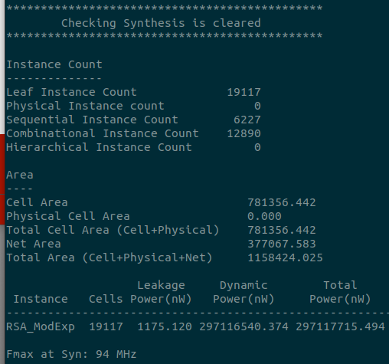100MHz